**Laboratory 4: Population Models with Age Specific Events**

**BSEN 5250/6250**

**What to Turn In:** Turn in your spreadsheet program and write-up.

The Alabama Department of Natural Resources is studying the deer population in a 200 square mile watershed on the Alabama River. The life history information of the population can be found in Table 9.3 of their research report (shown below). The initial number of males is 3351 and females are 4465. The initial number of hunters is 250. The purpose of this Lab is to develop a VBA model to simulate the age distribution of the population over time and to study the impact of management changes on population behavior. All of the equations for this lab were given in the class lecture notes and were taken from Chapter 9 in the Keen & Spain textbook.

* Step 1. Copy the template \files\Labs\Lab 4-Deer Simulation.xlsm from Canvas into your working directory.
* Step 2. Study the template and the underlying partial code included. Note that input variables are read into variable arrays where deer age is the index of the array. This makes it easier to utilize the variable values in a loop.
* Step 3. Develop the code to simulate deer population using a time step of 1 year. Set the model up to run for 100 years.
* Step 4. Develop a report answering questions 1 and 2 below and upload your word document and spreadsheet to Canvas.

**Question 1.** Describe the behavior of the system for different age classes. How does the system respond to changes in the number of hunters? How many hunters can safely hunt in this ecosystem without the deer population collapsing? Use thoughtful graphs to support your discussion. Think about what graphs you should develop to summarize your findings.

**Question 2.** Modify the carrying capacity equation by changing the CCAP coefficient from the default of 2.5 in a range from 1.3-3.0 to represent increases and decreases in food supply due to forest management. Note that CCAP is an input to your model defined in cell D4 in the spreadsheet. Rerun the model with different levels of hunters and carrying capacity levels and describe the long-term impacts on populations. Use thoughtful graphs to support your discussion. Think about what graphs you should develop to summarize your findings.

$$ΔN= \left(\sum{m_{x} F_{x}}\right) R \left[CCAP- \frac{1.5 \left(\sum{M_{x}+ \sum{F_{x}}}\right)}{6000}\right]$$

**Initial Conditions**

Initial total Males: 3351

Initial total Females: 4465

Area = 200 square miles

Initial Hunter Density: 250

Initial Carrying Capacity Coefficient (CCAP): 2.5

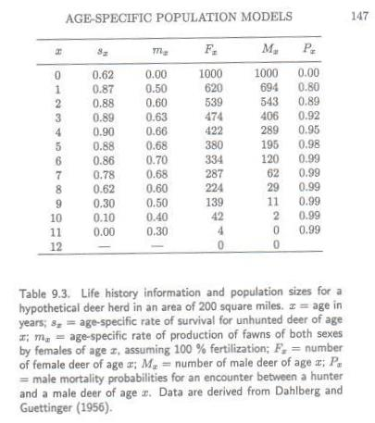

**Solution for Carrying Capacity of 2.5 and 250 Hunters**

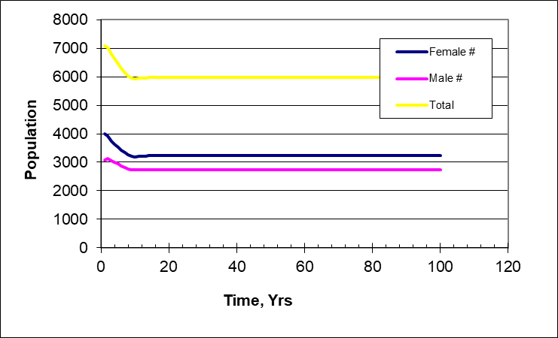

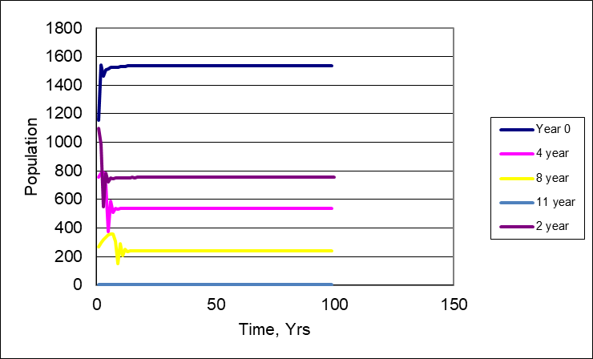

**Question 1**

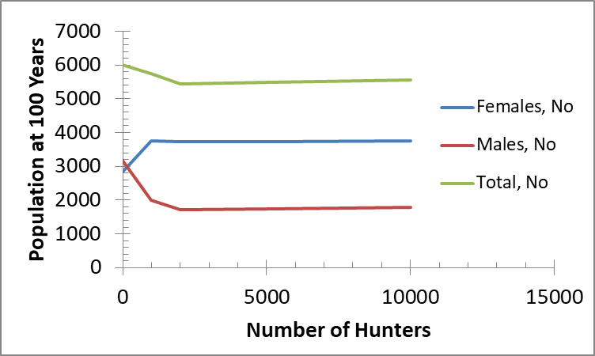

**Question 2**

